MY SQL QUERIES

COFFEE SHOP SALES PROJECT

- CREATE coffee_shop_sales_db DATABASE

create database coffee_shop_sales_db;

- DATA TYPES OF DIFFERENT COLUMNS BEFORE CLEANING

describe coffee_shop_sales;

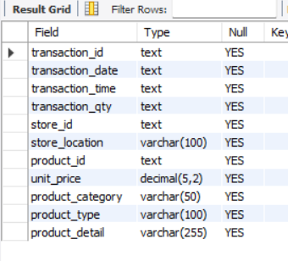

- CONVERT DATE (transaction_date) COLUMN TO PROPER DATE FORMAT

UPDATE coffee_shop_sales
SET transaction_date = STR_TO_DATE (transaction_date, '%d-%m-%Y');

- ALTER DATE (transaction_date) COLUMN TO DATE DATA TYPE
ALTER TABLE coffee_shop_sales
MODIFY COLUMN transaction_date DATE;

- ALTER DATE (transaction_id, store_id, product_id, transaction_qty) COLUMNS TO INTEGER DATA TYPE

- ALTER TABLE coffee_shop_sales
MODIFY COLUMN transaction_id INT;

- ALTER TABLE coffee_shop_sales
MODIFY COLUMN store_id INT;

- ALTER TABLE coffee_shop_sales
MODIFY COLUMN product_id INT;

- ALTER TABLE coffee_shop_sales
MODIFY COLUMN transaction_qty INT;

- CONVERT TIME (transaction_time) COLUMN TO PROPER DATE FORMAT
UPDATE coffee_shop_sales
SET transaction_time = STR_TO_DATE (transaction_time, '%H:%i:%s');

- ALTER TIME (transaction_time) COLUMN TO DATE DATA TYPE
ALTER TABLE coffee_shop_sales
MODIFY COLUMN transaction_time TIME;

- DATA TYPES OF DIFFERENT COLUMNS AFTER CLEANING
DESCRIBE coffee_shop_sales;
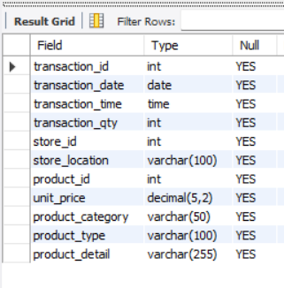

KPI's REQUIREMENTS

- TOTAL SALES ANALYSIS

a. Total Sales For Month
SELECT CONCAT(ROUND(SUM(unit_price * transaction_qty)/1000), "K") as Total_Sales
FROM coffee_shop_sales
WHERE MONTH(transaction_date) = 5; -- for month of (CM-May)
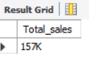

b. Total Sales KPI - Mom Difference And Mom Growth
SELECT
MONTH(transaction_date) AS Month ,
ROUND(SUM(unit_price * transaction_qty)) AS Total_Sales,
ROUND(SUM(unit_price * transaction_qty) - LAG(SUM(unit_price * transaction_qty), 1)
OVER (ORDER BY MONTH(transaction_date))) As Moth_Sales_Diff,
ROUND((SUM(unit_price * transaction_qty) - LAG(SUM(unit_price * transaction_qty), 1)
OVER (ORDER BY MONTH(transaction_date))) / LAG(SUM(unit_price * transaction_qty), 1)
OVER (ORDER BY MONTH(transaction_date)) * 100,1) AS MoM_Increase_Percentage
FROM
coffee_shop_sales
WHERE
MONTH(transaction_date) IN (4, 5) -- for months of April and May
GROUP BY
MONTH(transaction_date)
ORDER BY
MONTH(transaction_date);

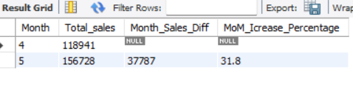

Explaination
SELECT clause:
- MONTH(transaction_date) AS Month: Extracts the month from the transaction_date column and renames it as month.
- ROUND(SUM(unit_price * transaction_qty)) AS Total_Sales: Calculates the total sales by multiplying unit_price and transaction_qty, then sums the result for each month. The ROUND function rounds the result to the nearest integer.
- (SUM(unit_price * transaction_qty) - LAG(SUM(unit_price * transaction_qty), 1) OVER (ORDER BY MONTH(transaction_date))) / LAG(SUM(unit_price * transaction_qty), 1) OVER (ORDER BY MONTH(transaction_date)) * 100 AS MoM_Increase_Percentage with the functions used:
  - SUM(unit_price * transaction_qty): This calculates the total sales for the current month. It multiplies the unit_price by the transaction_qty for each transaction and then sums up these values.
  - LAG(SUM(unit_price * transaction_qty), 1) OVER (ORDER BY MONTH(transaction_date)): This function retrieves the value of the total sales for the previous month. It uses the LAG window function to get the value of the SUM(unit_price * transaction_qty) from the previous row (previous month) ordered by the transaction_date.
  - (SUM(unit_price * transaction_qty) - LAG(SUM(unit_price * transaction_qty), 1) OVER (ORDER BY MONTH(transaction_date))): This part calculates the difference between the total sales of the current month and the total sales of the previous month.
  - LAG(SUM(unit_price * transaction_qty), 1) OVER (ORDER BY MONTH(transaction_date)): This function retrieves the value of the total sales for the previous month again. It's used in the denominator to calculate the percentage increase or decrease.
  - (SUM(unit_price * transaction_qty) - LAG(SUM(unit_price * transaction_qty), 1) OVER (ORDER BY MONTH(transaction_date))) / LAG(SUM(unit_price * transaction_qty), 1) OVER (ORDER BY MONTH(transaction_date)): This calculates the ratio of the difference in sales between the current and previous months to the total sales of the previous month. It represents the percentage increase or decrease in sales compared to the previous month.
  - 100: This part multiplies the ratio by 100 to convert it to a percentage.
- FROM clause:
coffee_shop_sales: Specifies the table from which data is being selected.
- WHERE clause:
MONTH(transaction_date) IN (4, 5): Filters the data to include only transactions from April and May.
- GROUP BY clause:
MONTH(transaction_date): Groups the results by month.
- ORDER BY clause:
MONTH(transaction_date): Orders the results by month.

- TOTAL ORDER ANALYSIS

a. Total Order For Month

SELECT COUNT (transaction_id) as Total_Orders
FROM coffee_shop_sales
WHERE MONTH (transaction_date) = 5; -- for month of (CM-May)

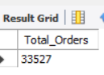

b. Total Orders KPI - Mom Difference And Mom Growth

SELECT
MONTH(transaction_date) AS Month,
ROUND(COUNT(transaction_id)) AS Total_Orders,
COUNT(transaction_id) - LAG(COUNT(transaction_id), 1)
OVER (ORDER BY MONTH(transaction_date)) AS Month_Order_Diff,
ROUND((COUNT(transaction_id) - LAG(COUNT(transaction_id), 1)
OVER (ORDER BY MONTH(transaction_date))) / LAG(COUNT(transaction_id), 1)
OVER (ORDER BY MONTH(transaction_date)) * 100,1) AS MoM_Increase_Percentage
FROM
coffee_shop_sales
WHERE
MONTH(transaction_date) IN (4, 5) -- for April and May
GROUP BY
MONTH(transaction_date)
ORDER BY
MONTH(transaction_date);
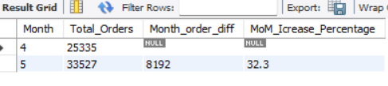
- TOTAL QUANTITY SOLD ANALYSIS

- Total Quantity Sold For Month

SELECT SUM(transaction_qty) as Total_Quantity_Sold
FROM coffee_shop_sales
WHERE MONTH(transaction_date) = 5; -- for month of (CM-May)
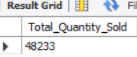

- Total Quantity Sold KPI - Mom Difference And Mom Growth

SELECT
MONTH(transaction_date) AS Month,
ROUND(SUM(transaction_qty)) AS Total_Quantity_Sold,
(SUM(transaction_qty) - LAG(SUM(transaction_qty), 1)
OVER (ORDER BY MONTH(transaction_date))) as Month_Sold_Quantiy_Diff,
ROUND((SUM(transaction_qty) - LAG(SUM(transaction_qty), 1)
OVER (ORDER BY MONTH(transaction_date))) / LAG(SUM(transaction_qty), 1)
OVER (ORDER BY MONTH(transaction_date)) * 100,1) AS MoM_Increase_Percentage
FROM
coffee_shop_sales
WHERE
MONTH(transaction_date) IN (4, 5) -- for April and May
GROUP BY
MONTH(transaction_date)
ORDER BY
MONTH(transaction_date);
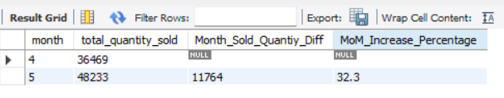
CHARTS REQUIREMENTS

- For Calendar Table – Daily Sales, Quantity And Total Orders

SELECT
ROUND(SUM(unit_price * transaction_qty)) AS Total_Sales,
COUNT(transaction_id) AS Total_Orders,
SUM(transaction_qty) AS Total_Quantity_Sold
FROM
coffee_shop_sales
WHERE
transaction_date = '2023-05-18'; -- For 18 May 2023
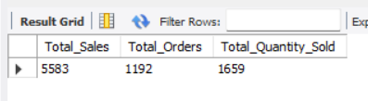

If you want to get exact Rounded off values then use below query to get the result:
SELECT
CONCAT(ROUND(SUM(unit_price * transaction_qty) / 1000, 1),'K') AS Total_Sales,
CONCAT(ROUND(COUNT(transaction_id) / 1000, 1),'K') AS Total_Orders,
CONCAT(ROUND(SUM(transaction_qty) / 1000, 1),'K') AS Total_Quantity_Sold

FROM
coffee_shop_sales
WHERE
transaction_date = '2023-05-18'; -- For 18 May 2023

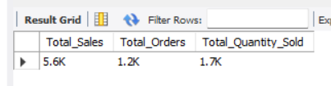

- Sales By Weekday / Weekend

SELECT
CASE
WHEN DAYOFWEEK (transaction_date) IN (1, 7) THEN 'Weekends'
ELSE 'Weekdays'
END AS Day_Type,
CONCAT (ROUND (SUM (unit_price * transaction_qty)/1000),'K') AS Total_Sales
FROM
coffee_shop_sales
WHERE
MONTH (transaction_date) = 5 -- For May
GROUP BY
CASE
WHEN DAYOFWEEK (transaction_date) IN (1, 7) THEN 'Weekends'
ELSE 'Weekdays'
END;
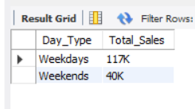

- Sales By Store Location

SELECT
Store_Location,
concat(round(SUM(unit_price * transaction_qty)/1000,2),'K') as Total_Sales
FROM coffee_shop_sales
WHERE
MONTH(transaction_date) =5 -- For May
GROUP BY Store_Location
ORDER BY Total_Sales DESC;
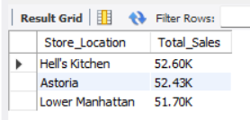

- Sales Trend Over Period

SELECT ROUND (AVG (total_sales)) AS Average_Sales
FROM (
SELECT
SUM (unit_price * transaction_qty) AS Total_Sales
FROM
coffee_shop_sales
WHERE
MONTH (transaction_date) = 5 -- For May
GROUP BY
transaction_date
) AS internal_query;

Query Explanation:
- This inner subquery calculates the total sales (unit_price * transaction_qty) for each date in May. It filters the data to include only transactions that occurred in May by using the MONTH() function to extract the month from the transaction_date column and filtering for May (month number 5).
- The GROUP BY clause groups the data by transaction_date, ensuring that the total sales are aggregated for each individual date in May.
- The outer query calculates the average of the total sales over all dates in May. It references the result of the inner subquery as a derived table named internal_query.
- The AVG() function calculates the average of the total_sales column from the derived table, giving us the average sales for May.
- ROUND function rounds the result to the nearest integer.
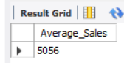

- Daily Sales For Month Selected

SELECT
DAY (transaction_date) AS Day_of_Month,
ROUND (SUM (unit_price * transaction_qty)) AS Total_Sales
FROM
coffee_shop_sales
WHERE
MONTH (transaction_date) = 5 -- For May
GROUP BY
DAY (transaction_date)
ORDER BY
DAY (transaction_date);

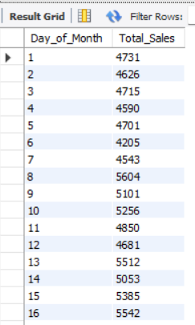
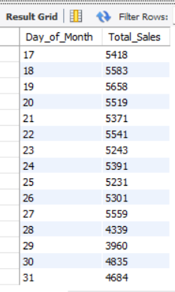

- COMPARING DAILY SALES WITH AVERAGE SALES – IF GREATER THAN “ABOVE AVERAGE” and LESSER THAN “BELOW AVERAGE”

SELECT
Day_of_Month,
CASE
WHEN total_sales > avg_sales THEN 'Above Average'
WHEN total_sales < avg_sales THEN 'Below Average'
ELSE 'Average'
END AS Sales_Status,
Avg_Sales,
Total_Sales
FROM (
SELECT
DAY (transaction_date) AS day_of_month,
ROUND (SUM (unit_price * transaction_qty)) AS total_sales,
ROUND (AVG (SUM (unit_price * transaction_qty)) OVER ()) AS avg_sales
FROM
coffee_shop_sales
WHERE
MONTH (transaction_date) = 5 -- For May
GROUP BY
DAY (transaction_date)
) AS sales_data
ORDER BY
day_of_month;

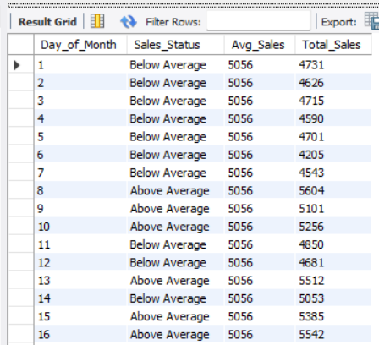
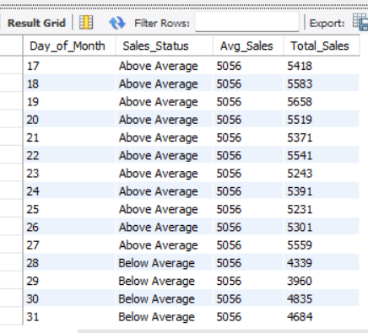

- Sales By Product Category

SELECT
Product_Category,
CONCAT (ROUND (SUM (unit_price * transaction_qty)/1000,2),'K') as Total_Sales
FROM coffee_shop_sales
WHERE
MONTH (transaction_date) = 5 -- For May
GROUP BY product_category
ORDER BY Total_Sales DESC;

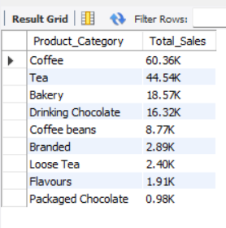

- Sales By Products (Top 10)

SELECT
Product_Type,
CONCAT(ROUND(SUM(unit_price * transaction_qty)/1000,2),'K') as Total_Sales
FROM coffee_shop_sales
WHERE
MONTH(transaction_date) = 5 -- For May
GROUP BY product_type
ORDER BY SUM(unit_price * transaction_qty) DESC
LIMIT 10;
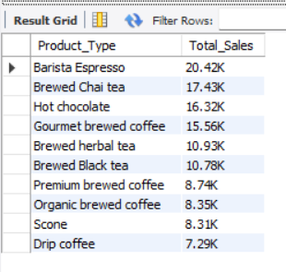
- Sales By Day | Hour

SELECT
ROUND(SUM(unit_price * transaction_qty)) AS Total_Sales,
COUNT(*) AS Total_Orders,
SUM(transaction_qty) AS Total_Quantity
FROM
coffee_shop_sales
WHERE
DAYOFWEEK(transaction_date) = 2 -- For Tuesday (1 is Sunday, 2 is Monday, ..., 7 is Saturday)
AND HOUR(transaction_time) = 8 -- For hour number 8
AND MONTH(transaction_date) = 5; -- For May

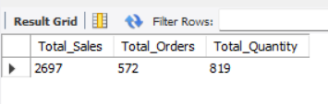

- To Get Sales For All Hours For Month

SELECT
HOUR(transaction_time) AS Hour_of_Day,
ROUND(SUM(unit_price * transaction_qty)) AS Total_Sales
FROM
coffee_shop_sales
WHERE
MONTH(transaction_date) = 5 -- For May
GROUP BY
HOUR(transaction_time)
ORDER BY
HOUR(transaction_time);
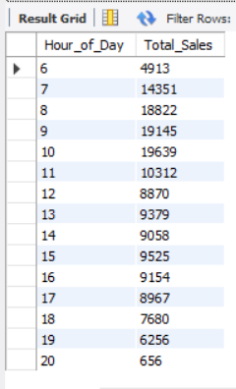

- To Get Sales From Monday To Sunday For Month

SELECT
CASE
WHEN DAYOFWEEK(transaction_date) = 2 THEN 'Monday'
WHEN DAYOFWEEK(transaction_date) = 3 THEN 'Tuesday'
WHEN DAYOFWEEK(transaction_date) = 4 THEN 'Wednesday'
WHEN DAYOFWEEK(transaction_date) = 5 THEN 'Thursday'
WHEN DAYOFWEEK(transaction_date) = 6 THEN 'Friday'
WHEN DAYOFWEEK(transaction_date) = 7 THEN 'Saturday'
ELSE 'Sunday'
END AS Day_of_Week,
CONCAT(ROUND(SUM(unit_price * transaction_qty)/1000),'K') AS Total_Sales
FROM
coffee_shop_sales
WHERE
MONTH(transaction_date) = 5 -- For May
GROUP BY
CASE
WHEN DAYOFWEEK(transaction_date) = 2 THEN 'Monday'
WHEN DAYOFWEEK(transaction_date) = 3 THEN 'Tuesday'
WHEN DAYOFWEEK(transaction_date) = 4 THEN 'Wednesday'
WHEN DAYOFWEEK(transaction_date) = 5 THEN 'Thursday'
WHEN DAYOFWEEK(transaction_date) = 6 THEN 'Friday'
WHEN DAYOFWEEK(transaction_date) = 7 THEN 'Saturday'
ELSE 'Sunday'
END;
